

Notorious RBG: The Life and Times of Ruth Bader Ginsberg
February 9 - August 16, 2020

DOCENT TOUR GUIDE


Notorious RBG: The Life and Times of Ruth Bader Ginsburg
EXHIBITION OVERVIEW - News Release Skirball Cultural Center, June 20, 2018
Notorious RBG: The Life and Times of Ruth Bader Ginsburg, is the first-ever exhibition about the trailblazing associate justice. Based on the New York Times bestselling book of the same name and created in partnership with its authors, Irin Carmon and Shana Knizhnik, the exhibition will take a deeply personal journey through historic change with an entertaining yet rigorous look at the life and work of Ruth Bader Ginsburg (RBG) and the Supreme Court. It will also examine her varied roles as a student, life partner, mother, change-making lawyer, judge, women’s rights pioneer, and pop culture icon.
Through archival photographs and documents, historical artifacts, contemporary art, media stations, and gallery interactives, the exhibition will explore the American legal system and civil rights movements through the lens of RBG’s personal experiences and public service. Like the book, it will tell the parallel stories of her remarkable life and the efforts she joined to expand “We the People” to include those long left out of the Constitution’s promises.
“Justice Ginsburg has never given up on doing the work of equality and justice, work that is needed now more than ever,” remarked Irin Carmon, a Washington Post contributing writer and co-author of the Notorious RBG book, which has sold more than 275,000 copies since its October 2015 publication. “We’re so thrilled that the exhibition will bring to life a genuinely inspirational story, while making it clear how we all have an urgent stake in the work and future of the court.”
Co-author Shana Knizhnik—who founded the popular Tumblr that made RBG an Internet sensation— explained, “I created the Notorious RBG blog as a law student in 2013, in response to Justice Ginsburg’s forceful dissent to the Supreme Court’s 5-4 decision to strike down part of the 1965 Voting Rights Act. I hoped to pay tribute to the Justice and her remarkable story, which has only become more inspirational as she continues to advocate for justice for all. I am pleased that this exhibition will illuminate, in its own way, the life and work of such a vital figure in American history.”
In keeping with Carmon and Knizhnik’s book, the exhibition will touch on the playful connection between Justice Ginsburg and the Notorious B.I.G.—both of whom were born and bred in Brooklyn, New York, as RBG herself has proudly pointed out. The title of each section riffs off a lyric by the late hip-hop artist:
• Introduction: “NOTORIOUS”
• Early Life and Education: “I GOT A STORY TO TELL”
• RBG as Activist: “STEREOTYPES OF A LADY MISUNDERSTOOD”
• Judge Ginsburg: “DON’T LET ‘EM HOLD YOU DOWN, REACH FOR THE STARS”
• Ruth and Marty: “REAL LOVE”
• Justice Ginsburg: “MY TEAM SUPREME”
• RBG Timeline (1848–2018): “BEEN IN THIS GAME FOR YEARS”
Skirball Associate Curator Cate Thurston, who has developed the exhibition with Carmon and Knizhnik over more than two years, added, “Woven throughout the exhibition will be briefs and other writings by RBG, including some of her most famously searing dissents. A range of objects will then give context to the Justice’s place in history.” These include official portraits of her and Sandra Day O’Connor, the first two women to serve on the Supreme Court, on loan from the National Portrait Gallery; and correspondence with civil rights leader, poet, and lawyer Pauli Murray, whose groundbreaking idea to use the Fourteenth Amendment to litigate civil rights and sex discrimination cases informed RBG’s winning strategy as an attorney for the American Civil Liberties Union.
Three-dimensional environments will bring key moments to life, such as recreations of Justice Ginsburg’s childhood Brooklyn apartment and of the Supreme Court bench, where visitors can take a seat and imagine making their own opinions heard. Visitors will also gain insight into RBG’s marriage to Martin “Marty” Ginsburg, her partner of more than fifty years, through family snapshots and other materials from their life together, including some of Marty’s favorite recipes as the accomplished amateur chef of the Ginsburg household. Finally, reflecting RBG’s effect on pop culture, Notorious RBG will include contemporary art and expression that she has inspired, by such artists as Maira Kalman, Roxana Alger Geffen, and Ari Richter.

Photography Policy: Photography is NOT allowed in this exhibit.
Non-flash photography is allowed in TWO PLACES ONLY. - the RBG graphic silhouette portrait wall, and the “Supreme Court bench” area.

What is Dialogue?
This tour relies heavily on Dialogue. This does not refer to the dialogue between the educator and the students. It means the students will be in dialogue with one another. As a docent, you will be responsible for guiding the conversation and keeping focus. The tour is structured with activities that will help you do this.
The following tips are adapted from a workshop on facilitating dialogue, organized by the International Coalition of Sites of Conscience:
What is Dialogue?
- Dialogue is a learning process, not simply a communication tool. Dialogue enables people to “make meaning” by learning with, from and about one another.
- In dialogue, “book knowledge” and “experiential knowledge” are both valued and welcome.
- Good dialogue invites people to share their personal stories and hear the stories of others in order to identify a “larger truth.”
- Dialogue requires people to listen honestly and intentionally to one another so people are often exposed to perspectives and viewpoints that they had previously negated, denied or rejected.
Dialogue Facilitators…
- Maintain necessary group safety (no domination, no judgment)
- Help group establish and abide its own guidelines
- Model active listening and ensure that students do not talk over one another
- Maintain a “shared center” of focus and group engagement
- Facilitate dialogue without imposing own beliefs/perspectives
- Help Group synthesize its own ideas
THEMES
- Upstanders vs. Bystanders
- Justice
- Equality
- Choices

Notorious RBG Dedicated Tours

Field Trips
Length: 1 hour 45 minutes
Times: 10:00 AM, 12:00 PM, 2:00 PM, and 5:00 PM (Thursday evenings)
Weekends: 10:00 AM, 12:00 PM, and 2:00 PM
Group Size: 80 students *
Tour includes:
- Notorious RBG: The Life and Times of Ruth Bader Ginsburg (45 minutes)
- Take a Stand Galleries: (45 Minutes)

Introduction: 7 minutes
Early Life and Education: 7 minutes
Law School and Early Work: 7 minutes
RBG as Activist, Lawyer, Judge 7 minutes
Make A Difference Activity 7 minutes
RBG and the Supreme Court 5 minutes
Conclusion 5 minutes
TAS: 45 minutes (see cards for rotations)

STUDENT TOUR OVERVIEW
Notorious RBG: The Life and Times of Ruth Bader Ginsburg offers a visually rich and engaging look at the Justice’s life and career presenting a unique take on the American legal system and civic rights movements through the lens of Ginsburg’s personal experiences and public service. Students will learn the parallel stories of Ginsburg’s remarkable life and the ongoing expansion of “We the People” to include those long left out of the Constitution’s promises, examining her continuing work to protect civil rights and equal opportunity for all.
Students will also explore the Take a Stand Center to learn about other contemporary Upstanders working to achieve greater equality through judicial and non-judicial means. Our Take a Stand Center includes the Goodman Upstander Gallery, highlighting 40 change-makers working toward civil, social, economic, health and environmental rights; civics focused Take A Stand Lab, exploring how to raise awareness, give, advocate, and participate; and The Act of Art Gallery, stimulating the idea of citizen artistry as a response to human rights issues.

GOALS
- Understand civic engagement and social action as fundamental values of a democratic society.
- Learn about the federal court system.
- Feel moved and inspired by the content of the exhibition - Ruth Bader Ginsburg is a woman with a lifelong commitment to equality, justice, and the ideals of American law. She has lived through history and shaped it; faced adversity and lived passionately.
- Inspire students to find ways that they can help their own communities be just and fair.

FIELD TRIP APPROACH
Introduction (7 minutes)
“Today we will visit an exhibition about Supreme Court Justice Ruth Bader Ginsburg’s life and work. We will explore four BIG ideas:
- How her lived experiences shaped her character and contributed to the values of respect, persistence, and courage that she embodies. A true upstander.
- The importance of role models in RBG’s life and in our own lives.
- The importance of being able to disagree but still be able to respectful.
- The active role can do to Take a Stand in helping our communities be just and fair.
“Take a minute and look at this mural on the wall.”
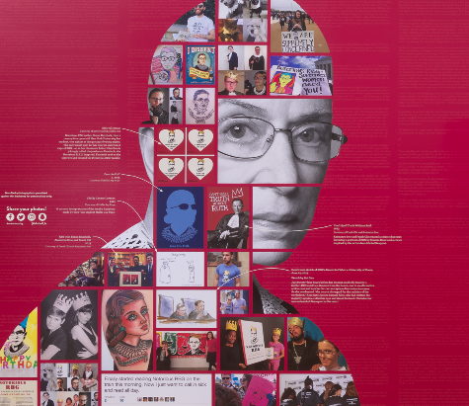
Ask: “What are your impressions of this person? What do you know about RBG?”
As students respond, docent will share background information on RBG. Some examples below.
- “RBG is a real person who is 86 years old (will be 87 on March 15).”
- “She did not always have that job, she was once a student like you, worked hard to get a good education, became a lawyer, then a judge, and then much later was appointed to the lifelong job of Supreme Court Justice.”
“We will spend about 45 minutes in this exhibition (customize time period according to tour length), and I will allow you time to explore different sections on your own, coming back together at a group at different points for discussion.”

Ask: “Tell me why you think the Museum might choose to host an exhibition like this?”

OPTIONAL Additional ideas you can share below:

- Share how she became Notorious at age 80 by dissenting or having a difference of opinion.
- A dissent is a formal disagreement with a ruling by other judges, disputing the courts majority opinion.
- Shelby v. Holder case, 2013 - one of RBG’s major dissents was in the Supreme Court case involving race discrimination. This case overturned key provisions of the Voting Rights Act of 1965, which gave people more equal access to vote.
- RBG gave an angry dissent, compared getting rid of the provision against discrimination to “ throwing away your umbrella in a rainstorm because you’re not getting wet.”
- Outrage over the decision and admiration for RBG’s vocal dissent gave rise to a number of memes that quickly spread on social media. One was the image of RBG wearing a crown with the words, “You Can’t spell Truth Without Ruth.” Another was simply “Notorious RBG,” first publicized via a Tumblr site created by NYU law student Shana Knizhnik (whose roommate first used the phrase your Facebook page). Shana and a journalist named Irin Carmon later wrote a bestselling book called Notorious RBG which was the inspiration behind this exhibit. This is how RBG became Notorious.
- RBG embraced the comparison to late American rapper Notorious B.I.G. (also known as Biggie), noting that both she and Biggie were Brooklynites who could pack a strong verbal punch. The section headings in the exhibition, like the chapters of the book, are all based on lyrics from Notorious B.I.G. lyrics.

Ask: “What are the three branches of government? What is the role of the Supreme Court? How do the three branches complement each other?”
- Legislative - Makes the laws
- Executive - Carries out the laws
- Judicial - Evaluates the Laws
Ask: “How many cases does the SCOTUS hear?” Out of 7000 they hear 75.
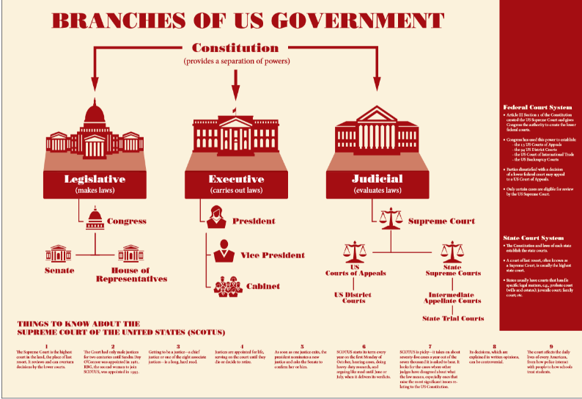

Transition: “Today you will see artifacts, documents, and photographs that chronicle the life and time of Supreme Court Justice Ruth Bader Ginsburg. Let’s get to know more about her early life and the people who shaped her.”

- Early Life and Education: - (7 minutes)
  - Ask: “Can you find interesting facts about Ruth’s life as a child?” Give students 5 minutes to explore and then pair/share what they found. Then share out to larger group one interesting fact.
  - Ask: “Ruth’s mother saved $8000 for her education in the 40’s. What do you think that is worth today? (About $110,000). What are some key ideas RBG learned from her years at Cornell? What was life like in college for RBG? Why did she like about Marty? What was life like in Law School for RBG? Why did RBG struggle when she and Marty lived at Fort Still Army Base in Oklahoma? How did RBG show examples in her early life of being an upstander? Were there any formative or pivotal moments?”
  - Look at the large wall graphic, “Things Women Couldn’t Do” Ask: “Is anything listed here surprising to you? What is different today?”
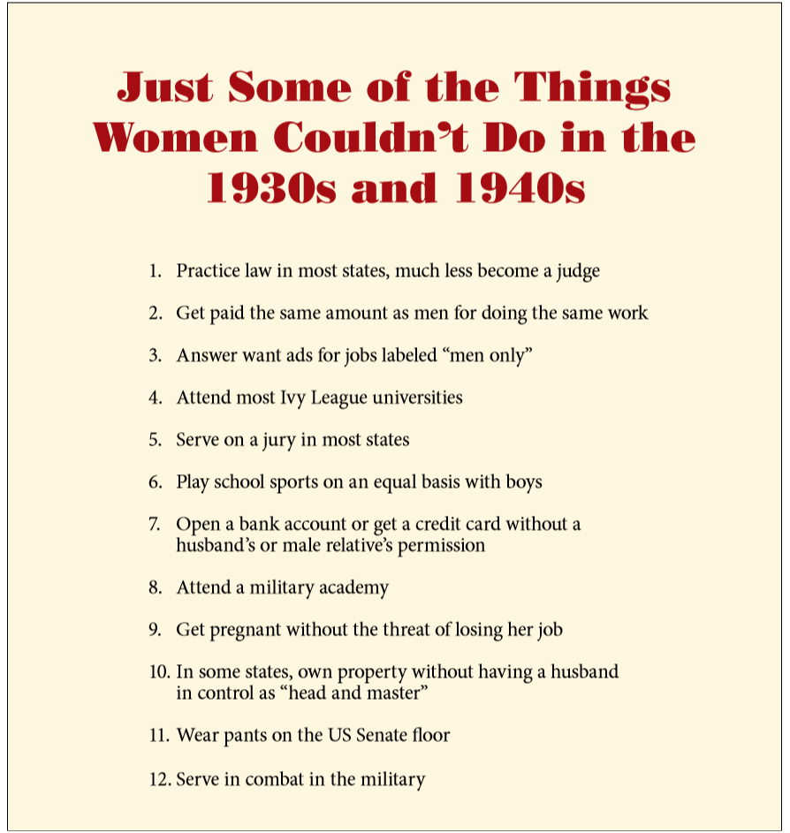
  - Marty and Ruth Section: “Marty is an example of love, support, and equality. As a couple, they equally shared the responsibilities of work and home. They even decided that they would pursue careers together. Ruth learned lawyers could fight unfairness and prejudice in courts. Professor Vladimir Nabokov at Cornell influenced her and helped her gain writing and editing skills, which she uses today. RBG quote about writing; “make it right, keep it tight.””

Transition: Now that we know a little bit more about RBG’s early life, let us find out how she started her work life.
- Law School and Early Work (5 minutes)
Like many women of her generation, Ruth encountered closed doors and obstacles. Set up RBG as someone who experienced discrimination herself and dedicated her career to fighting it and making the country a better place for men and women.
- Let students explore for a few minutes.
- “RBG was one of 9 women in her Law School Class.” ASK: “How might this have been a challenge for her?” Tell the story of how the dean asked the women why they felt they deserved a spot that a man could hold.
- Show the map and how they put work and school on hold to go to Oklahoma to complete Marty’s mandatory military service. Describe how RBG was demoted when they found out she was pregnant.
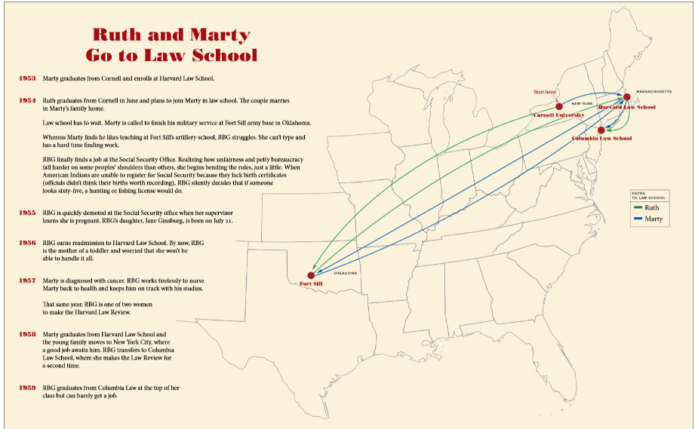
Transition: “Now we know a lot more about the people and values that inspired her. Let’s see how she does as a young lawyer.”
- RBG as a Lawyer, Activist, and Judge (7 minutes)
“Women (and men) were being treated unfairly under the law, RBG and others became agents of change, promoting justice for ALL. RBG took on cases of every size and type to end gender-based discrimination.”

ASK: “What is activism? What is gender-based discrimination? Can men experience gender-based discrimination?” You can share information about the Moritz case here. See Appendix A.
- Let students explore area for 5 minutes. Have them take note of people that inspired RBG. Have them share if there is time.

- Share about Pauli Murray - and how RBG listed her on her first brief even though she did not co-author.
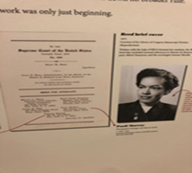
- Movement & Pair Share Activity - Set the parameters of the space. Explain that when students are prompted to “cover the space,” they will move within the set of parameters at their own normal pace. As they move, they will pay attention to where their bodies are in relation to one another’s. As they move, they want to keep the bodies equally distributed throughout the space, so keep an eye on where empty spots pop up and think about how your own body can fill that empty space as you move around.
  - Tell participants to “cover the space” and how them to move around for a minute. As you pass people, make eye contact. Finally, as you walk, think about someone in your life is a mentor to you or someone who motivates you.
  - FREEZE! Find the person closest to you and pair up. You’ll each have 1 minute to share about someone in your life who is a mentor to you or someone who motivates you.
  - When I say GO, cover the space just like before. This time as you walk, think about a moment when you helped or motivated someone else.
  - FREEZE! Find the person closet to you and pair up. You’ll each have 1 minute to share about a moment when you helped or motivated someone else.
Transition: “Now that we’ve had a chance to reflect on role models in our lives and the ways we have helped others, let's learn about how RBG helped people as a lawyer and judge, working to create a more equal society for men and women.”

- Make Difference Activity (5 minutes) - examples of cases that RBG took on as an ACLU lawyer or judge. Docents should pick one interesting case. See Appendix A for Examples.
- Docent shares the big idea of a case. (example: postal hat case)
- Ask: “What is a plaintiff? What does the plaintiff want?”
- Barometer Activity: A barometer teaching strategy helps students share their opinions by lining up along a continuum to represent their point of view. It is useful when trying to discuss an issue about which students shave a wide range of opinions. Ask students to take a stand on the issues being presented. If you agree with the plaintiff stand on the right, if you disagree, stand on the left, undecided in the middle. Share your thoughts with the people standing with you. Decide as a group on how you are going to present your argument.
- Each side presents their argument for or against the plaintiff; the other side listens and responds; thank the students for listening to the other side in a respectful way.
- Docent shares the verdict that was reached in the case.

- RBG and the Supreme Court - (5 minutes)
Explain RBG’s nomination to the Supreme Court. Share basic info on the Supreme Court - the highest court of law in the United States, whose function is to interpret the laws set forth in the U.S. Constitution. As people demand equality, laws are changing because the Constitution is a living document. The Supreme Court is important because it rules on cases that affect many aspects of our lives.

ASK:
“How do you think the court has changed over time?
How do you think RBG and the other Justices get along?
How do you think it was possible for RBG and A. Scalia to be such good friends?”

Teacher Photo Opportunity at the bench. No dress up for students not enough robes.
- Conclusion - 3 minutes
Ask: “Please share one word or phrase about what we experienced today.”
“What does this exhibit have to do with our permanent exhibit?”
Transition: Now that we have learned how RBG has led her life as an upstander who fights daily for equality and justice for all. Lets learn about other global, national, and local upstanders and then see how we can take action in our Take a Stand Center.

Notorious RBG - 20 Minutes- “In Our Voices”, “Make A Difference”, and “Be an Upstander” Tours.
** for MAD and Be an Upstander tours you can chose between RBG and They Shall be Counted**
Introduction: 5 minutes
Early Life and Education: 5 minutes
RBG and the Supreme Court 5 minutes
Conclusion 5 minutes

Introduction: Same as dedicated tour above

Early Life and Education: - (5 minutes)
  - Ask: “Can you find interesting facts about Ruth’s life as a child?” Give students 5 minutes to explore and then pair/share what they found. Then share out to larger group one interesting fact.
  - Ask: “Ruth’s mother saved $8000 for her education in the 40’s. What do you think that is worth today? (About $110,000). What are some key ideas RBG learned from her years at Cornell? What was life like in college for RBG? Why did she like about Marty? What was life like in Law School for RBG? Why did RBG struggle when she and Marty lived at Fort Still Army Base in Oklahoma? How did RBG show examples in her early life of being an upstander? Were there any formative or pivotal moments?”
  - Look at the large wall graphic, “Things Women Couldn’t Do” Ask: “Is anything listed here surprising to you? What is different today?”

RBG and the Supreme Court - (5 minutes)
Explain RBG’s nomination to the Supreme Court. Share basic info on the Supreme Court - the highest court of law in the United States, whose function is to interpret the laws set forth in the U.S. Constitution. As people demand equality, laws are changing because the Constitution is a living document. The Supreme Court is important because it rules on cases that affect many aspects of our lives.

Ask:
“How do you think the court has changed over time?
What do you think Quote on desk means? “Fight for the things you care about but do it in a way that will lead others to join you.”
How do you think RBG and the other Justices get along?
How do you think it was possible for RBG and A. Scalia to be such good friends?”
Teacher Photo Opportunity at the bench. No dress up for students not enough robes.

Conclusion - 3 minutes
Ask: “Please share one word or phrase about what we experienced today.”
“What does this exhibit have to do with our permanent exhibit?”
Transition to Karkomi: Now that we have learned how RBG has led her life as an upstander who fights daily for equality and justice for all we are going to visit our Karkomi Permanent exhibit. We will also see similar themes of upstanders/bystanders, choices, and equality.

Group Tours for Adults
Length: 45 Minutes
Times: By request
Group Size: 60 maximum
Tour includes: TBD by the group

Adult Tour - 45 minutes

This tour will focus around dialogue around different artifacts.

Goals:
- How the Supreme Court Functions
- Learn that while our institutions seem fixed they can and do change over time
- RBG does the work when it is hard, when it seems impossible, and perhaps more importantly she does the work when no one is looking - exhibition is a celebration of showing up and working hard whatever your beliefs may be.

Introduction: See Student Tour Introduction

- Justice Ginsburg’s Robe
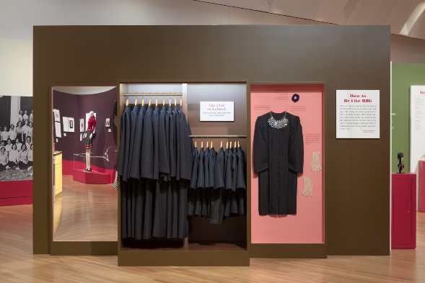

- Introduce the exhibitions big themes by RBG’s robe and jabot. People respond to these items, and they convey the right weight to counter the whimsical tone of the show. Point out that the robes Supreme Court justice’s wear are based on the robes worn by English barristers.
- Draw visitors attention to the jabot, there is an opening in the robe at the very top that is designed to reveal a tie or bow tie. RBG’s jabot is a profoundly feminine gesture, making what was previously a uniform only for men, her own. Note that she is not the first justice to embellish her work uniform.
- Justice Sandra Day O’Connor, the first women nominated and confirmed to the Supreme Court in 1981 also wore necklaces, collars, and jabots.
- Chief Justice William Rehnquist who added epaulettes down his sleeve for a very jaunty Pirates of Penzance kind of look.

ASK: “Why is it important to point out that RBG custom created her robe and Jabots?”


- Lolita Book
- This object because it is surprising, you don’t think Lolita- Supreme Court Justice. The tension between those ideas focuses attention. One of the threads throughout the show is the impact of sex-based discrimination and that it can have large impacts like pay inequality and discrimination and also more benign impacts that still have a profound impact.
- At Cornell RBG noted women had a curfew, where-as men did not, women had to live in the dorms, where as men did not, these funny arbitrary rules made no sense other than to reemphasize the point that women are different and women are lesser. That said, Cornell was an incredibly positive experience for RBG and it opened up her world view to the difficulties in contemporary American life and American history.
- One of her Professors was Vladmir Nabokov who she credits with really teaching her how to write. Like many of us RBG’s writing as a teen was flowery and adjective heavy, Nabokov emphasized thinking carefully about the placement of every word. Today, RBG is widely viewed as one of the sharpest writers on the court her motto is “make it right, keep it tight” she intentionally writes short briefs in plain English so that the general public can read and understand Supreme Court decisions.
- If you have time it is also worth noting that the curator choose this particular work by Nabokov because it was written while he was a professor at Cornell. Additionally, Lolita was banned in the U.S. when it was first released because of the subject matter and RBG is a staunch supporter of free speech.

ASK: “Why is this such an interesting artifact? Why is writing so important to RBG?”

- Law School Photo
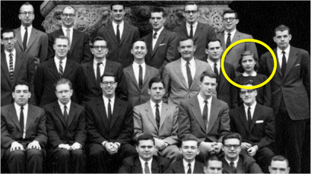

- Focus attention the Harvard Law School Review Picture. The thread of sexism is very evident in this object, the photographer positioned the two women who made the law review on either side of the group and referred to them as “roses amongst the thorns” at every turn at Harvard Law School made it clear RBG was different because she was a woman. For example there was no women’s bathroom in the law school building and it wasn’t until a pregnant student told the male students that she was “using their bathroom whether they liked it or not” that things changed. RBG couldn’t check some legal citations because certain reading rooms were “men only”. The feeling of “otherness” permeated this experience but RBG kept going. When things get hard, RBG works harder.

ASK “How did RBG persevere during these years?”
- Swedish Judicial System Book and Fundraising letter

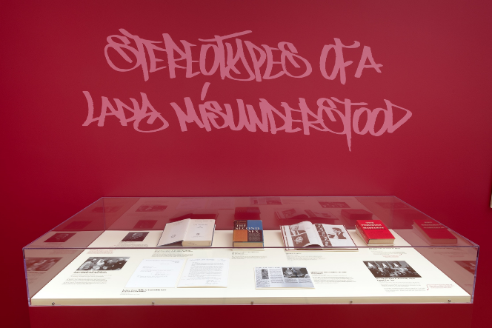

- Life after law school, any object in the case works. I recommend underscoring the point that despite graduating at the top of her class no one would hire her because as RBG put it, she was “a woman, a mother and a Jew.”
- A Columbia professor of hers had to blackmail a federal judge to get her a position, telling him that is he didn’t take her he’d never give the judge another clerk but that if she didn’t work out he’d find a male replacement. RBG was not replaced.
- After her clerkship when the doors of law firm are tentatively opening to her RBG realized that this isn’t what she wanted anymore and took an opportunity to write a book on the Swedish legal system category which she joking called the “best” book on the Swedish legal system in English as it was the only book on the Swedish legal system for some time.
- Fundraising letter - in this letter RBG notes that perhaps female donors would respond more favorably to donation appeals if they are included in the ask. The big point is that in the 70’s the idea of using men and women or women and men versus blanket use of male pronouns was pretty radical, today we are having our own conversations of pronouns and some people find that radical.

ASK: “Why do you think RBG went to Sweden?”

- Postal Caps
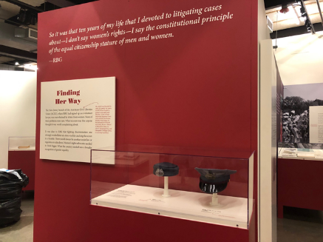
- Along with teaching RBG also started volunteering at the New Jersey branch of the American Civil Liberties Union (ACLU), this office was overwhelmed by letters from women. None of their problems were new. What was new was that anyone thought it was worth complaining about.
- On August 20, 1971, a female letter carrier in Springfield, New Jersey, wrote to the New Jersey chapter of the ACLU to complain that she wasn’t allowed to wear the same hat that men wore. “The female carrier hats, a beret or a pillbox, have no place on which to attach my badge,” Laney Kaplan explained in her letter. “The male carrier hat has a brim to keep the sun from your eyes, which the female carrier hats have none.”
- Here’s that thread of sexism again. Sometimes equal rights is about big macro issues and sometimes it’s as basic as wanting the sun out of your eye. No case was too small for RBG. “The insistence on sexual identification by headgear for female letter carriers at the expense of functional features that would facilitate job performance appears to be wholly arbitrary,” RBG wrote to the postmaster general. The man may not have known what hit him.
- The dress code rule was changed but RBG realized she would need a strategy. It was clear to her that fighting discrimination one strongly worded letter at a time was like catching the ocean in a thimble. There would always be another sexist law or regulation to take down. Women’s rights advocates needed to think bigger. What the country needed was a broader recognition of gender equality.

ASK: “What do you find interesting about this case? Is there anything relatable to this case today?”

- Pauli Murray:
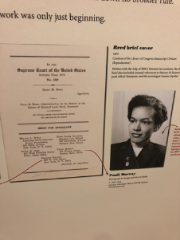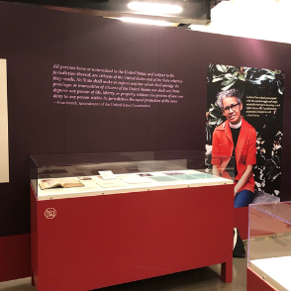
- She’s an incredibly important figure and the main takeaway is her idea to use the equal protection clause of the the 14th Amendment shapes RBG’s thinking about how to litigate sex based discrimination. The answer is already in the constitution, all people regardless of gender or citizenship are subject to equal treatment and equal protection under the law. This idea was used by future Supreme Court Justice Thurgood Marshall in his arguments for Brown v. Board of Education 1954 and clears a path to litigate sex based discrimination cases when RBG combines Murray’s ideas with the idea to take male applicants, and changes America’s legal landscape.
- RBG used men to demonstrate that sex based discrimination hurts men and women equally. Murray was under recognized in her own life and is now getting the overdue attention she deserves. Any of the objects in this case work. Murray’s letter is a good artifact to point out where you get a sense of the humor and her accomplishments.

ASK “Why did RBG include Pauli Murray’s name on her first Supreme Court Brief? Why was it a good strategy to demonstrate that sex based discrimination hurts men and women equally?”

- ERA - Bracelet
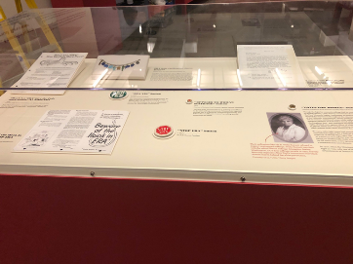
- The passage of the ERA would have given RBG a clearer way to litigate sex based discrimination cases instead she had to get creative.
- Bracelet was created by suffragist and feminist Alice Paul. The piece is on loan from the National Museum of American History and it’s a really wonderful artifact.
- Alice Paul wrote the text for what would become the Equal Rights Amendment in the twenties. The ERA was finally passed by the House and Senate in 1971 before it was sent to the states for ratification. Everything was on track until a woman named Phyllis Schlafly led a grass roots collation of women in opposition to the ERA.
- Schlafly opposed the ERA for a variety of reasons, most of which are pretty shocking today-the movement used blatantly homophobic language and scare tactics.
- The story has a hopeful-ish ending, the ERA is being revived and recently was ratified by Schlafly’s home state of Illinois, these victories are largely symbolic because the amendment was given a ten year date of expiration that ended in 1981. However, that expiration date is also being challenged. The 27th amendment dealing with congressional pay raises was formally adopted in the nineties after working it’s way through house legislatures for over 200 hundred years. The amendment was originally authored by James Madison! So the question is now being asked why did the pay raise amendment get 200 plus years but equal rights gets ten measly years. If one more state ratifies the amendment symbolically it would pass, which means a potential court challenge regarding the date of expiration.

ASK: “Why would a woman Phyllis Schalfly be opposed to the ERA?” Does anyone know how many states of ratified the ERA?”

- Harvard Law School Yearbook
- This object was a sleeper hit at Skirball. You can see the misspelling of her name from Mrs. (which she hated anyway, she’s been using Ms. Since the 60’s) to Mr. Ginsburg. Visitors always ask if this was intentional, which it was not.
ASK: “What challenges do you think RBG had in law school?”

- The Susan Struck case
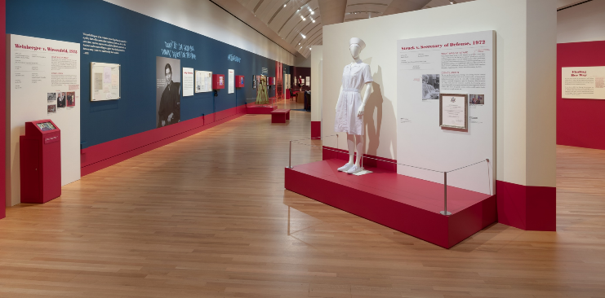
- This case that deals with reproductive rights. Skirball not encounter any issues or anger about our inclusion of this material and it is essential to RBG’s career!
- Recognize that reproductive freedom is a hot button issue which is why we introduce visitors to the topic with a women who did not want an abortion.
- The point is one of freedom that every person should be able to make choices about their own body and that includes the right to not have an abortion.
- RBG’s career is about expanding the group of people the constitution refers to in it’s opening line and creating a world where everyone is free to pursue their goals and live a meaningful life of their choosing and that will always include the ability to plan to have or not have a family.

Appendix A:
Case Summaries
Reed v. Reed (1971)
- Situation: Sally and Cecil Reed were a married couple who separated, and their son died. According to Idaho Probate code, “males must be preferred to females,” and so Cecil was automatically appointed administrator of their son’s estate. Sally sued Cecil.
- Plaintiff’s argument: The 14th amendment does not allow for discrimination based on gender.
- Defendant’s argument: This preference for males is “mandatory” and therefore Cecil should remain administrator.
- Decision and impact: 7-0 in favor of Sally Reed, and Idaho removed the preference.
Moritz v. Commissioner of Internal Revenue (1972)
- Note: This case was argued before the U.S. Court of Appeals for the Tenth Circuit.
- Situation: Charles Moritz was an unmarried man taking care of his mother. In 1968, he claimed a tax deduction from Section 214 of the Internal Revenue Code for caregiving expenses. The IRS refused the deduction, because he was never married and a man.
- Plaintiff’s argument: The fact that this deduction is only available to women, widowers, divorcés, and husbands with incapacitated wives is arbitrary and a denial of due process. o Defendant’s argument: Moritz did not fulfill the requirements outlined by Section 214.
- Decision and impact: 3-0 in favor of Moritz. The Internal Revenue Code was changed so all “individuals” could claim the deduction.

Struck v. Secretary of Defense (1972)
- Situation: While serving in Vietnam, air force Captain Susan R. Struck became pregnant. She was told she would be honorably discharged, unless she terminated the pregnancy. Captain Struck refused and was honorably discharged.
- Plaintiff’s argument: Captain Struck had been performing her job well for several months already while pregnant. For men in the military with pregnant wives, their “port call orders will not fall during the period six weeks before or six weeks after expected delivery.” Therefore, the honorable discharge is arbitrary, deprives her of her liberty without due process, and violates the Fifth Amendment. By saying the discharge would be cancelled if the pregnancy is terminated, the air force violated the First Amendment, as she is a Roman Catholic and thus she could not undergo an abortion.
- Defendant’s argument: The military is concerned about the health of the mother and unborn child, and did not intend to violate Captain Struck’s First Amendment rights.
- Decision and impact: No decision. Solicitor General Griswold predicted a loss and persuaded the air force to stop automatically discharging pregnant officers. RBG said, "The idea was: 'Government, stay out of this.' I wish that would have been the first case. The court would have better understood this is a question of a woman's choice."
Frontiero v. Richardson (1973)
- Situation: Air force lieutenant Sharron Frontiero requested a dependent’s allowance for her husband. Wives of military members automatically became dependents, but husbands of military members needed to receive at least half his material support from his wife. Frontiero’s request was denied.
- Plaintiff’s argument: This is unconstitutional discrimination against Lt. Frontiero.
- Defendant’s argument: Because it’s assumed that men are breadwinners and women are dependents, the army was saving money by not having to verify every application.
- Decision and impact: 8-0 in favor of Lt. Frontiero. Judges undecided on how to proceed with scrutinizing gender-based restrictions.
Weinberger v. Wiesenfeld (1975)
- Note: This case was argued at the District Court for the District of New Jersey, decided in favor of Wiesenfeld. Weinberger appealed, which is why he is now listed as plaintiff.
- Situation: Stephen Wiesenfeld’s wife, Paula Polatschek, died in childbirth, leaving him responsible for their infant. Wiesenfeld applied for social security benefits, which his son received, but he was denied. In the case of spousal death, widows received benefits for themselves and their children, but widowers did not while their children did.
- Plaintiff’s argument: Typically, men are the breadwinners and thus they do not need social security benefits. This is not meant to be an automatic payment, but a way to support women to primarily take care of her children.
- Defendant’s argument: This is unconstitutional discrimination as it is treating men and women differently, just like in Frontiero v. Richardson.
- Decision and impact: 8-0 for Wiesenfeld. Widowers can now collect social security benefits. RBG said this case highlighted that child-rearing was not solely women’s responsibility, and that parents should have equal partnership in raising their children.
Craig v. Boren (1976)
- Situation: In Oklahoma, beer was prohibited for men under the age of 21 and women under the age of 18. Curtis Craig, a man 18-21 years old, and Carolyn Whitener, an alcohol vendor, challenged the law.
- Plaintiff’s argument: Like in Reed, this was gender-based discrimination, and it also violated the Twenty-First Amendment.
- Defendant’s argument: This difference in treatment is due to safety, as women have fewer DWIs than men.
- Decision and impact: 7-2 for Craig. This case established a method of intermediate scrutiny for evaluating gender discrimination cases. In this method, challenged laws must (a) further an important government interest, and (b) do so by means substantially related to that interest.
U.S. v. Virginia (1996)
- Situation: The Virginia Military Institute was VA’s only male-only undergraduate school. They were sued for violating the Fourteenth Amendment. They won, and the U.S. appealed. The Fourth Circuit found VMI’s admissions policy to be unconstitutional, and VMI responded by creating the Virginia Women’s Institute for Leadership, which the Fourth Circuit found acceptable; despite the differing levels of prestige, the schools would offer “substantially comparable” educational benefits. The U.S. appealed.
- Plaintiff’s argument: Accommodations for women can be made while maintaining the quality education that VMI provides. Additionally, VMI’s goal of “producing citizen soldiers” is not inherently unsuitable to women.
- Defendant’s argument: Male-only education at VMI offers certain educational benefits, and making accommodations for women would inevitably destroy those benefits.
- Decision and impact: 7-1 for the U.S. VMI was considering becoming private, so the Fourteenth Amendment would not apply, but they ultimately decided to become coed.
- RBG’s opinion: This was the first majority opinion that RBG wrote. It was notable for its plain and accessible language. In it, she cited cases she won as a lawyer for the ACLU, including Weinberger v. Wiesenfeld, Frontiero v. Richardson, Reed v. Reed, and Craig v. Boren.
Bush v. Gore (2000)
- Situation: Neither Vice President Al Gore nor Governor George Bush had enough electoral votes to win the presidency in 2000. Florida’s votes were contested, and would determine the winner. Gore requested a recount by hand in four counties, but it was not completed by the deadline. The Florida Supreme Court decided to order a statewide recount, which was not part of Florida’s voting laws. Bush requested an emergency stay.
- Plaintiff’s argument: Because counties were using different standards to determine which votes counted, this was a violation of the Fourteenth Amendment.
- Defendant’s argument: Because there were five times as many “undervotes” (votes that did not indicate a vote for President) in counties that used punch-cards than in counties with voting machines, the recount was necessary for determining the “clear intent of the voter,” which was a uniform standard according to Florida’s voting laws.
- Decision and impact: 7-2 for Bush, that the method of recounting was unconstitutional. 5-4 for Bush that no other method could be decided and executed within election time limit. Bush received Florida’s votes, and eventually the presidency.
- RBG’s dissent: She dissented on both counts. She said that, for reasons of federalism, the recount should have been respected, as the Constitution requires that every vote be counted.
Ledbetter v. Goodyear Tire & Rubber Co (2007)
- Situation: Lilly Ledbetter, a Goodyear manager, found an anonymous note in her locker saying that her salary was $15,000 less than male managers’ salary. However, the Civil Rights Act of 1964 stated that discrimination complaints must be filed within 180 days of the incident.
- Plaintiff’s argument: Ledbetter was being discriminated against because of her gender each time she was issued a paycheck; the statute of limitations was reset every two weeks. o Defendant’s argument: The act of being issued a paycheck was, in itself, not discrimination. Therefore, Ledbetter’s complaint was beyond the statute of limitations.
- Decision and impact: 5-4 for Goodyear, as the act of discrimination happened when her salary was set, and the statute of limitations had passed.
- RBG’s dissent: RBG called on Congress to correct the situation. The Lilly Ledbetter Fair Pay Act, which reset the statute of limitations each time a paycheck is issued in payrelated discrimination cases, was signed in 2009.
Shelby v. Holder (2013)
- Situation: Section 5 of the Voting Rights Act requires certain districts with a history of discrimination (e.g. voting tests in the 1960s, low voter registration) to obtain preapproval from the federal government to make changes to their voting laws. Shelby County in Alabama claimed this was unconstitutional.
- Plaintiff’s argument: Article 4 in the Constitution guarantees the right of self-governance for each state. Also, the guidelines for defining a district with a history of discrimination is “based on an old formula” that no longer has contemporary relevance.
- Defendant’s argument: There is sufficient evidence that the districts requiring preapproval still require it.
- Decision and impact: 5-4 for Shelby County. Section 5 was deemed unconstitutional.
- RBG’s dissent: Despite discrimination in voting decreasing, "throwing out preclearance when it has worked and is continuing to work to stop discriminatory changes is like throwing away your umbrella in a rainstorm because you are not getting wet."

